

Institute of Computer Science



in the field of study Computer Science

and specialisation Computer Systems and Networks

Detection and mitigation of Slow HTTP POST attack

Anatolii Do

student record book number 309762

thesis supervisor

mgr inz. Paweł Radziszewski

WARSAW 2024

**Detection and mitigation of Slow HTTP POST attack**

**Abstract.** TODO

**Contents**

**1.** **Introduction** 5

**1.1. Description of the work** 5

**1.1.1. Motivation** 5

**1.1.2. Delimitation** 7

**1.1.3. Goal of the work** 8

**1.1.4. Research questions** 8

**1.1.5. Structure of the work** 8

**2.** **Theoretical background and related works** 9

**2.1. Denial of Service** 9

**2.2. Application layer Denial of Service** 10

**2.3. Slow HTTP Denial of Service attacks** 10

**2.4. Slow HTTP attack targets** 16

**2.5 Attacking Tools** 17

**Bibliography** 18

**List of Figures** 18

**List of Tables** 18

1. **Introduction**

Over the past few decades, the Internet has become a vital part of modern society, revolutionizing the ways we communicate, conduct business, and access information. Its invasive influence spans various sectors: from personal communication and entertainment to political and economic processes. Businesses, in particular, have embraced the power of the Internet to reach global markets, introduce on-line operations, and enhance productivity. Nowadays, it is common for successful enterprises to run a web asset, that constitutes the major source of their profit. The profound reliance on this technology emphasizes once again its undisputable importance for today’s world.  
  
However, such heavy dependence on the Internet also brings significant risks. As more critical operations move online, the ground for cyberattacks expands along with it and, as the result, the development of new protection mechanisms has become an increasingly urgent task. One of the most spread cyber threats are Denial of Service (DoS) and its variant Distributed Denial of Service (DDoS). In fact, the first major cyberattack the world has encountered was the DoS attack [1].

Denial of Service is a malicious action to disrupt the normal functioning of a server, service, or network by overwhelming its resources with excessive internet traffic. This overloads the system's resources, making it unable to respond to legitimate user requests. The effects of a successful DoS attack can be serious, as they are aimed on including temporary service outages, prolonged downtime, and significant financial and reputational losses [2]. When DoS attack is initiated from many distributed sources, for example a botnet, such attack is called Distributed Denial of Service (DDoS).

One type of DoS attacks is Slow HTTP POST (a.k.a. RUDY or Slow Body) attack, which is based on the use of the HTTP protocol and aimed at depleting server resources by sending slow HTTP POST requests. Unlike other types of DoS attacks, Slow HTTP POST attacks do not require a large number of requests or a botnet to achieve their goal. They can be carried out using just a few slow connections, making them particularly dangerous and difficult to detect.

The purpose of this thesis is to study and develop methods to detect and mitigate a particular type of DoS attacks — Slow HTTP POST. This work will discuss the basics of Slow HTTP POST attacks, common defense strategies, including the use of modern techniques. An analysis will be made of the effectiveness of various protection methods and the limitations one may face when using them.

## **1.1. Description of the work**

### **1.1.1. Motivation**

Even though DoS attacks exist since computer networks boom, they are well studied, and many anti-DoS solutions have been made up today (cloud, software, hardware, and even powered by AI), there are still no ideal protection, capable of elimination 100% of the threats. One should remember that any security is a process, not a result. Criminals constantly evolve, finding new vulnerabilities and exploiting them, and the defenders always have to adapt to new threats, making the situation to resemble a “Tom and Jerry” animation series.

In 2023, the cybersecurity landscape has witnessed a marked increase in DoS attacks, with a notable rise in the use of application-layer attacks such as Slow HTTP attacks. According to the "ENISA Threat Landscape 2023" report, DoS/DDoS attacks accounted for approximately 20% of all incidents, being the second threat in the chart.



**Figure 1.1.** Breakdown of analyzed incidents by threat type. ENISA Threat Landscape 2023 [3]

Speaking of the DoS/DDoS attacks aside, they are increasing both in terms of size and complexity, reaching 4.5 million attacks mitigated in Q1 2024 by Cloudflare, 37% of which were HTTP type attacks [3]. The report highlighted that Slow HTTP attacks have become more frequent and sophisticated, exploiting vulnerabilities in web server configurations and the HTTP protocol itself. The report indicated a 25% year-over-year increase in such attacks, emphasizing the urgent need for robust detection and mitigation mechanisms.

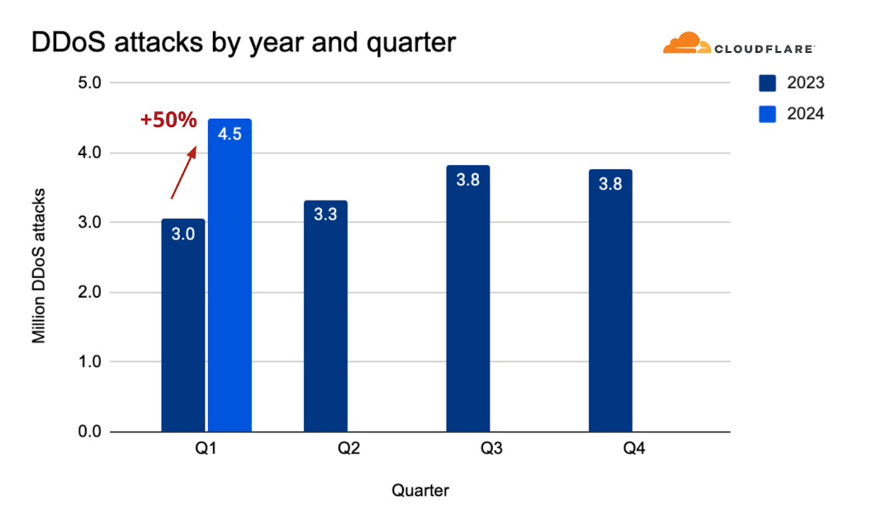

**Figure 1.2.** DDoS attacks by year and quarter. Source [4].

A particularly dangerous aspect of slow HTTP DoS/DDoS attacks is its ability to merge with legitimate traffic, that is typical to users with slow Internet connection. This feature makes the detection by traditional IDS/IPS (Intrusion Detection/Prevention Systems) a challenging task. This type of attack can be launched from a single computer and does not require many resources from attacker due to the principal of exploit’s operation, which will be described in detail in chapter 2 of this work. The vulnerability is easy exploitable, thanks to readily available tools, such as “R.U.D.Y.” and “Slowloris”, that will be reviewed later. This accessibility increases the potential for these attacks to be carried out by a wide range of adversaries, from ‘script-kiddies’ to advanced hackers.

General mitigation strategies of slow HTTP POST attacks typically involve adjusting web-server configurations, handling whole incoming traffic, rather than malicious packets only and may worsen the overall performance of the webserver together with user experience, for example, making the service not available for users with slow Internet.

### **1.1.2. Delimitation**

In further, this thesis will focus on using the Apache web server as a primary testing ground for Slow HTTP attacks due to several reasons.

First is the nature of the attack. Apache is a thread-based server, which makes it more vulnerable to Slow HTTP attacks compared to event-based servers like Nginx. In a thread-based architecture, each incoming connection is handled by a separate thread. Slow HTTP attacks take advantage of this by keeping many connections open for a long time, which ties up server resources like memory and CPU. On the other hand, event-based servers use a single-threaded, non-blocking approach to deal with multiple concurrent connections, making them less vulnerable to these types of attacks.

Second, Apache is one of the most widely used web servers globally. As of June 2024, it powers about 30% of all active websites, according to W3Techs [5]. By focusing on Apache, the findings of this research can benefit a large number of websites and organizations, making the research more impactful.

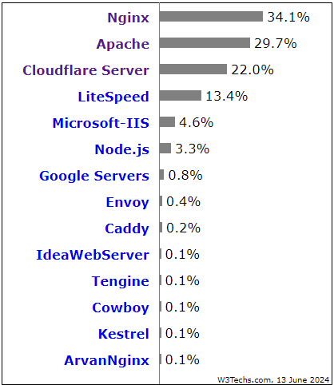

**Figure 1.3.** Percentages of websites using various web servers. [5]

Third, Apache’s open-source nature is a big advantage for research purposes. It allows us to freely modify and configure the server to create various attack scenarios and test different mitigation strategies. In addition, Apache supports adjustable security modules. This flexibility is essential for thoroughly understanding Slow HTTP attacks and developing effective solutions.

### **1.1.3. Goal of the work**

Aim of this work is to design and implement a solution that effectively detects and mitigates slow HTTP POST attacks. This will be achieved by focusing on behavior patterns, used by common attacking tools. This involves understanding the nature of how these attacks operate and the signatures they leave behind in web traffic. Other main objectives include:

1. Study common mitigation strategies, that can be done on Apache web server.
2. Conduct comprehensive tests to evaluate the performance of the solution, simulating various attack scenarios without adverse effect on legitimate traffic
3. Analysis of the test results to measure the accuracy, efficiency and reliability of the solution.

### **1.1.4. Research questions**

TODO

### **1.1.5. Structure of the work**

TODO

1. **Theoretical background and related works**

## **2.1. Denial of Service**

Denial of service attacks are a security threat where an attacker sends a large number of fake requests to a host or server, causing the target host to deny access to authorized users. Consequently, the service from the host becomes unavailable, compromising the system's availability – one of the three fundamental concepts of the information security, dictated by CIA triad[1]. When a denial-of-service attack is launched from multiple computers, it is called a Distributed Denial of Service (DDoS) attack, which has become the most used type of DoS attack due to prevalence of botnets, consisted of thousands of compromised hosts.

Due to the wide variety of attacks, classifying them is helpful in clarifying the process of defending against DoS attacks. The classification of DoS attacks is shown in Figure 2.1:



**Figure 2.1.** The classification of Denial of Service attacks. Source [6]

**Network device level attacks** focus on overwhelming the network infrastructure such as routers, switches and firewalls with aim to disrupt communication between networked devices.

**Data Flood attacks** target with excessive data, leading to bandwidth saturation or exhausting system resources. These attacks aim to consume the available bandwidth or processing power of the target system. They include simple flooding (via ICMP Ping or UDP flooding), amplifier attacks (DNS or NTP amplification attack), and oscillation attacks (that force the target system constantly switch between states or operations, exhausting resources).

**Operating System (OS) level attacks** exploit vulnerabilities in the target's operating system to cause system crashes or freezes (Ping of Death attack, the Teardrop attack, and the WinNuke). During Ping of Death, ICMP echo requests with a total size greater than the maximum IP packet size are sent to the potential victim. This attack often leads to a malfunction of the operating system, as it is associated with the implementation features of the TCP/IP protocol stack.

**Protocol level attacks** use standard protocol features. For example, some attacks take advantage of the fact that the sender's IP address can be spoofed. Some are DNS-focused and attack DNS server caches. An attacker with his own name server can force the attacked DNS to place a false entry in its cache that does not correspond to the destination address. Such attack is called Name Resolution Attack.

## **2.2. Application layer Denial of Service**

Application layer DoS attacks target the 7th abstraction layer of the OSI reference model[2], aiming to exhaust specific application resources that work on application-level protocols (such as HTTP, DNS, FTP, SMTP, SSH, POP, etc.). These resources can be CPU, memory or concurrent database connections limit, which are usually significantly smaller than the number of concurrent TCP connections. Because of that, such attacks do not require many resources to  
initiate, making them accessible to wider range of attackers.

Unlike volumetric attacks, which try to overwhelm the networks with high traffic (flood), application layers attacks use legitimate-looking, low-bandwidth requests to deplete server resources. This stealthy approach makes detection of the attack by traditional anti-DoS/DDoS tools challenging, as they often search for anomalies, such as huge subsequent attempts to establish SYN-ACK handshakes[3]. In case of application-level attacks, it is required to successfully establish the connection before launching them.

Since malicious packets merge within legitimate-looking traffic, they often bypass traditional defense mechanisms like firewalls and intrusion detection systems (IDS). Advanced techniques such as rate limiting and anomaly detection must be employed, which can be resource-intensive, difficult to configure and often have negative impact on user performance. Moreover, strong hardware of the attacked server

The subject of this research, slow HTTP POST attack, is a type of slow application layer DoS attack.

## **2.3. Slow HTTP Denial of Service attacks**

Slow HTTP Denial of Service (DoS) attacks are a subset of application layer attacks, performed in low bandwidth, that exploit the HTTP protocol to exhaust server resources. The core principle of these attacks is to hold server connections open for as long as possible, exploiting keep-alive mechanism of HTTP protocol. This is achieved by sending keep-alive HTTP messages in subsequent packet’s body, before it reaches keep-alive time-out and opening new connections, to exhaust available resources such as memory or CPU and preventing legitimate users from accessing the service.

Three known types of Slow HTTP DoS were first described and categorized in [7]. According to the research, this type of attack can be classified into four categories:

1. **Slow HTTP Headers (a.k.a. slow HTTP GET or Slowloris).** Named after its execution tool, Slowloris attack firstly establishes connection with the attacked server, then sends HTTP GET requests along with incomplete HTTP Header. The protocol was designed in a way, that it needs a complete GET message’s header to be completely received before its processing. If, for some reason, it failed to receive a complete GET header, server waits (approximately 26 seconds) [8] for complete request, assuming that client has slow network connection. The attacker sends next HTTP Header just before this time out, so that the server cannot release the allocated resources and open a new connection. Eventually, the attacked server has to maintain many parallel connections which results in resource starvation, causing Denial of Service. Figure 2.2. below illustrates the traffic pattern during the Slow HTTP Headers attack:

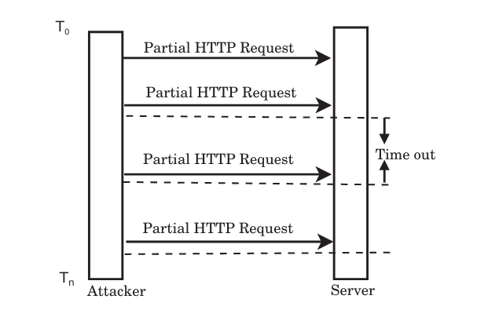

**Figure 2.2.** Slowloris attack. Source [9]

According to RFC2616 (HTTP protocol specification standard), CR LF (carriage return and linefeed) line “\r\n” defines the end of the line in HTTP header, while   
“\r\n\r\n” is defined as the end of whole header and beginning of message body [12]. When exploiting this feature, attacker sends “\r\n” sequence without the complete CRLF, making server to wait for this remaining part. Simultaneously, new connections are opened, that eventually occupy all server connection limit and preventing legitimate users from connecting. Proper HTTP Header must contain “\r\n\r\n” (0d 0a 0d 0a) combination in the end, like it is shown on Figure 2.3. below:



**Figure 2.3.** Normal HTTP header. Source [10]

Example of a bogus Slowloris header is presented below in Figure 2.4:

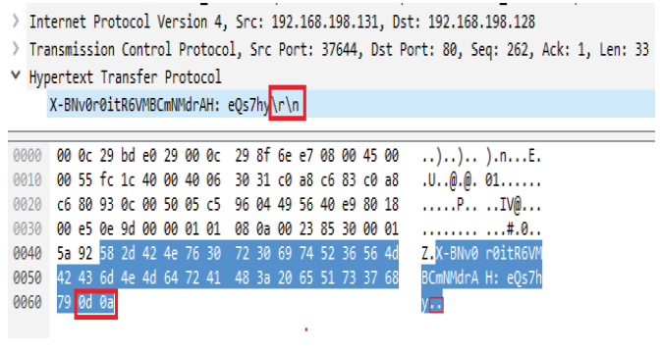

**Figure 2.4.** Slowloris header. Source [10]

Figure 2.5. demonstrates network traffic during a Slowloris attack, captured by Wireshark analyzer:



**Figure 2.5.** Slowloris attack. Source [10]

1. **Slow HTTP Body (a.k.a. slow HTTP POST or RUDY).** Also called after hacking tool, RUDY attack, after establishing a stable TCP connection with the server,  
   sends complete HTTP Header, but HTTP body has large Content-Length value, so that server must wait (around 300 seconds) [8] until it receives the entire body, before closing the connection. The content is sent in small 1-byte chunks within POST requests at very slow rate, as if it was sent from a host with slow Internet connection. This results in tying up server resources and making them unavailable for legitimate users after several long simultaneous connections reach server’s limits.

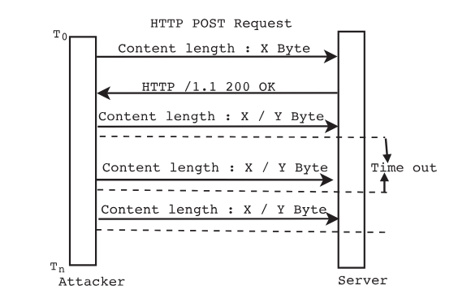

**Figure 2.6.** Slow HTTP POST attack. Source [9]

Figure below shows an example of a normal HTTP POST packet.

  
**Figure 2.7.** Healthy HTTP header. Source [10]

Please note that ‘Content Length’ header has adequate value of 75. In a typical POST request, the client sends the body of the request quickly after transmitting the headers. The data is usually sent in a single burst or within a few packets, depending on the network conditions and the size of the data. This means the connection is kept open only for a short time, proportional to the amount of data being sent. In contrast, malicious HTTP request’s ‘Content-length’ field is an unusually large value, like 1000000 (Figure 2.8), and the data is transmitted at extremely low rate (usually 1 byte per message). Such behavior creates a massive backlog of the server’s threads, while it cannot close the connection until long ‘Content-length’ is received completely and, eventually, the connection table clogs with spoiled traffic and the application cannot serve legit clients.



**Figure 2.8.** Malicious HTTP header. Source [10]

Figure 2.9 represents one of the attacks’ packet streams, captured by Wireshark and

Figure 2.10 sheds some light on the slow HTTP POST header and body. Take a note on content-length here which is 10000 bytes. When server waits for remaining data, the attacker just sends 27 bytes, following by 1-byte chunks (characters ‘A’) with 100 seconds intervals (the default timeout value of ‘OWASP Switchblade’ attacking tool that will be described later in the chapter). The whole attack took around 300 seconds ending up in Denial of Service.



**Figure 2.9.** Traffic during RUDY attack. Source [10]

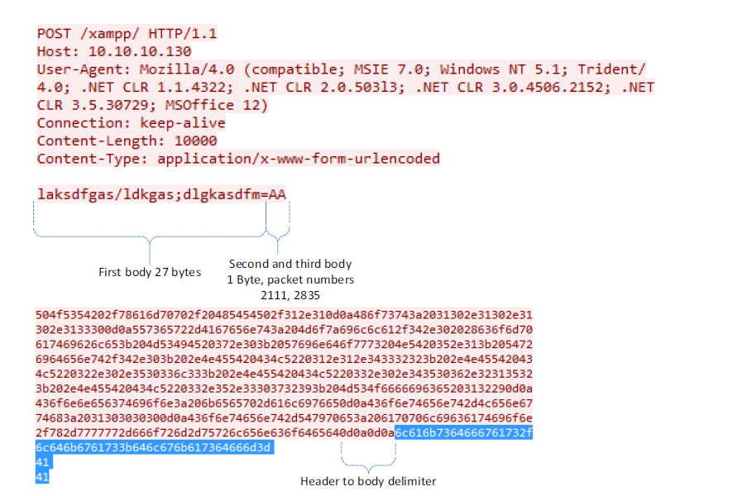

**Figure 2.10.** Incomplete HTTP body with hex dump. Source [10]

1. **Slow Read attack.** During a Slow Read Attack, attackers deplete server resources by keeping connection opened by requesting a document with HTTP GET request, sending proper header and body to the targeted web server. Once TCP connection established, the value of TCP window size is being manipulated. TCP windows size is number of bytes the data receiver, or browser, can receive on TCP session. Attacker frequently sets this window to be relatively small, just few bytes, or even zero, and then requests for relatively large piece of data. This makes the host to fail sending the data, keeping its resources busy with attempts to reach the request source. Many active connections being opened in this way, resulting in occupying all server’s available resources and denial of service. This attack is implemented in Slowhttptest tool.

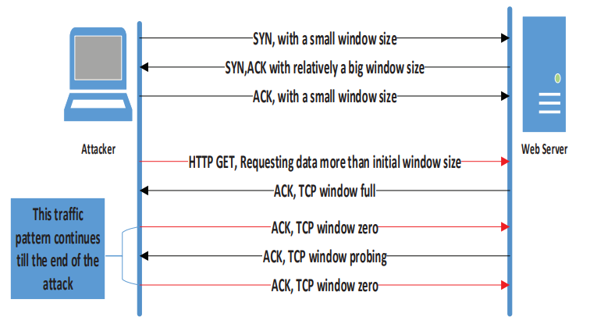

**Figure 2.11.** Slow HTTP Read attack. Source [10]

1. **Apache Killer (Range) attack.** The HTTP data transfer process from a server to a client can sometimes be interrupted before completion by cancelling request or dropping the connection. In such cases, the client can request the remaining portion of the data using an HTTP 'Range' request. This allows the client to specify the part of the content it failed to receive. The Range attack, known as Apache Killer, exploits the Apache Server processing range requests method. In this attack, the attacker sends many overlapping bytes range requests for a single URL. When the server receives these range requests, it generates multiple segments of a multipart response for each specified range. The excessive number of overlapping byte ranges overwhelms the server, leading to overconsumption of memory and CPU resources, eventually exhausting the server's capacity to function properly.  
   Although this vulnerability was patched along with introduction versions 2.2.20 and 2.2.21 of Apache [11], this attack is still in use, threatening companies that neglect cybersecurity measures and use outdated software.

## **2.4. Slow HTTP attack targets**

It has been already mentioned multiple times that Slow HTTP attacks focus on holding several connections opened for extended periods, slowly disrupting the performance by targeting the server’s handling multiple connections method.

Web servers operate under two predominant architectures: **thread-driven** and **event-driven**. Each type has its own strengths and weaknesses in handling HTTP requests, and both respond differently to Slow HTTP attacks. Understanding these architectures and how they are targeted can provide valuable insights into which systems are more vulnerable.

1. **Thread-driven web servers (e.g. Apache, Microsoft IIS)** handle multiple client requests by allocating a separate thread (or process) and utilizing limited pool of threads. Each thread operates independently from others, processing the entire lifecycle of the request (from receipt to response). If arriving requests exceed number available threads, the server may spawn new threads or queue the requests. In this model, threads typically block (pause) while waiting for resources (e.g., I/O operations such as reading files or querying databases). This provides predictable behavior when user’s requests follow a linear, step-by-step model. In addition, if crash or error occur in one thread, generally, it does not affect other threads. Thread-driven servers provide a more traditional, linear approach to handling requests but face scalability limitations when managing many simultaneous connections as each thread consumes system resources. Such models ideal to be used when there expected to be fewer concurrent connections and systems resources are limited.
2. **Event-Driven Web Servers (e.g., NGINX, Node.js)** handle requests through asynchronous event loop using a non-blocking I/O model with single thread instead of assigning a thread to each request. When a request triggers an I/O operation (e.g., file access or network response), the server continues processing other requests in parallel, until the I/O operation completes. Once it finishes, the event loop processes the response. This makes event-driven architectures generally more scalable because a single thread can handle thousands of connections through efficient event handling with low resource consumption. However, such architecture is more complex to implement and understand, especially when dealing with asynchronous programming patterns (such as callbacks) and they better be deployed when thousands of concurrent connections and I/O-bound operations must be handled efficiently.

**Table 2.1** Thread-driven vs. event-driven servers.

|  |  |  |
| --- | --- | --- |
| **Feature** | **Thread-driven servers** | **Event-driven servers** |
| **Concurrency model** | Multiple threads, each handling a request | Single thread (can be few), handling requests through events |
| **I/O handling** | Blocking | Non-blocking, asynchronous |
| **Resource usage** | High resource usage, one thread per connection | Low resource usage, one (can be few) threads manage many connections |
| **Scalability** | Limited by number of threads | High scalability, handles thousands of connections efficiently |
| **Error isolation** | |  | | --- | |  |  |  | | --- | | Errors in one thread do not affect others | | Errors may affect the entire event loop |
| **Complexity** | Relatively simple to implement | More complex due to asynchronous programming |

**HTTP slow attacks** are highly effective against **thread-driven web servers** because of blocking nature of the latter. They exploit the fact that each slow connection monopolizes a thread, eventually exhausting server resources. In contrast, **event-driven web servers** are much more resilient to such attacks, as their non-blocking I/O and event-driven architecture allow them to handle large numbers of slow connections without significant resource consumption.

Speaking of the subject of this thesis work, RUDY attacks… TODO

## **2.5 HTTP Slow attacking tools**

…

**"R-U-Dead-Yet" or R.U.D.Y.** was first introduced in “Universal HTTP DoS – Are You Dead Yet?” cybersecurity article, posted by Raviv Raz[4] in 2010. Such ominous and rather descriptive name was inspired by an album of Finnish death metal band “Children of Bodom”. The tool has become so commonly used that whole class of slow HTTP POST attacks are now often called as “RUDY attacks”.

R-U-Dead-Yet can run in two modes: through interactive menu or from a configuration file.

Originally, this tool was written in Python which makes it available on all distributions of Linux with installed Python environment (including Windows 7 and above). However, thanks to open-source nature, there are available variations running on Go[5] and newer Python versions[6], since the original version is running Python 2 and was not updated since 2016.

The tool provides a simple command-line interface, allowing users to configure various parameters such as number of concurrent connections, interval between data chunks and including SOCKS proxy such as Tor.

Lack of graphical user interface makes it accessible even for less-experienced attackers with limited technical knowledge.

To start the attack, it is enough to run the r-u-dead-yet-v2.2.py script with fully qualified domain name link (URL) of the web page we want to exploit. After that, the tool crawls the website or web application until it finds form fields. If any, attacker is prompted to select the form and then tool scans for parameters available for attacking. Finally, attack options (no. of concurrent connections, interval and proxy) are specified and attack starts.

///

As of the moment of writing this work, the latest version posted by original author and available publicly is v2.2.

**OWASP Switchblade (HTTP DoS)** is another open-sourceprogram, that allows to perform DoS attacks on web application. It was developed in collaboration between OWASP (Open Web Application Security Project) and ProactiveRISK by Tom Brennan[7] to give developers an opportunity to test the resilience of their web applications against different types of DoS attacks. It supports three attack types: Slow HTTP POST, Slowloris, and SSL Renegotiation. However, it can handle only 40 000 simultaneous connections, which may require a larger network or botnet to successfully run some attacks.

This tool was designed to run on Windows (starting from Windows 7) platforms and includes user-friendly GUI where one can select the type of attack, target URL, and adjust both general and attack-specific parameters such as connections number, rate, and so on. For higher stealthiness, it is also possible to randomize “Content-Length” header value, packet timeouts, payload and changing “User-agent” field.

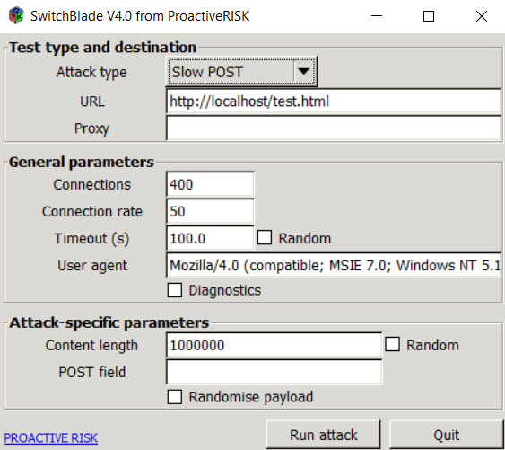

**Figure 2.12.** Interface of OWASP Switchblade.

As of now, the latest version of OWASP Switchblade available is v4.0.

**Slowhttptest** …

# **Bibliography**

[1]<https://www.fbi.gov/news/stories/morris-worm-30-years-since-first-major-attack-on-internet-110218>

[2]<https://www.kaspersky.com/about/press-releases/2015_collateral-damage-26-of-ddos-attacks-lead-to-data-loss>

[3] <https://www.enisa.europa.eu/publications/enisa-threat-landscape-2023>

[4]<https://blog.cloudflare.com/ddos-threat-report-for-2024-q1>  
[5] <https://w3techs.com/technologies/overview/web_server>

[6]<https://www.researchgate.net/publication/323194627_A_Review_of_Defense_Against_Slow_HTTP_Attack>

[7]<https://www.researchgate.net/publication/242654051_Slow_DoS_Attacks_definition_and_categorisation>

[8] <https://ieeexplore.ieee.org/stamp/stamp.jsp?tp=&arnumber=7784605>

[9] <https://ieeexplore.ieee.org/stamp/stamp.jsp?tp=&arnumber=8300082>

[10] <https://ieeexplore.ieee.org/stamp/stamp.jsp?tp=&arnumber=8246453>

[11] <https://httpd.apache.org/security/vulnerabilities_22.html>

[12] <https://datatracker.ietf.org/doc/html/rfc2616>

# **List of Figures**

TODO

# **List of Tables**

TODO

1. https://www.fortinet.com/resources/cyberglossary/cia-triad
2. https://en.wikipedia.org/wiki/OSI_model
3. https://www.geeksforgeeks.org/tcp-3-way-handshake-process/
4. <https://chaptersinwebsecurity.blogspot.com/2010/11/universal-http-dos-are-you-dead-yet.html>
5. <https://github.com/darkweak/rudy>
6. <https://github.com/SergiDelta/rudy>
7. <https://github.com/proactiveRISK/switchblade>